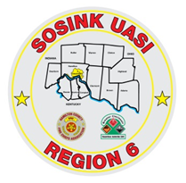
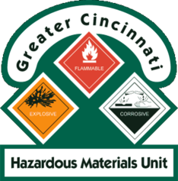
Activity Report
GCHMU
March – April 2018
Runs:
3/5/2018: Chemical Mixture (Toluene, Benzene, Styrene) – Consultation – City of Carlisle Fire
3/6/2018: Calcium Carbonate – Consultation – Village of New Richmond Fire
3/7/2018: Acetylene – Administrative Response – Village of New Richmond Fire
3/14/2018: Cyanide/Multiple Chemicals – Administrative Response - City of Amelia Police
Diesel Fuel – Consultation – City of Norwood
3/25/2018: Diesel Fuel – Consultation - City of Franklin
4/20/2018: Mercury – Consultation – Green Township Fire
Community Events/Unit Participation:
None
Training Completed:
- Monthly In House Training – PPE – 3/10/2018
- Warren County LEPC TTX – 3/15/2018
- Monthly In House Training- Paper Use - 4/14/2018
- Clermont County LEPC Tabletop Exercise – April 23rd

Training Opportunities/Upcoming Events:
- Ripley County, IN FSE – April 28th
- Hamilton County LEPC TTX – May 9th
- Sharonville Touch A Truck – June 4th
- PER 222 Public Safety Sampling Response – Sept 11th -13th

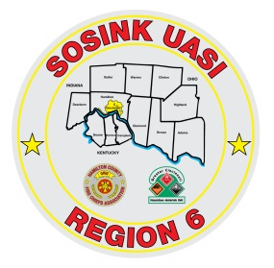
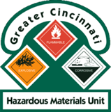
Activity Report
Command 400
March - April 2018
Activations:
None to date
Community Events/Unit Participation:
- Warren County Fire Chief’s Meeting (Presentation) 4/5/2018
- Warren County Telecomm Open House 4/10/2018
- Glendale Show and Tell 4/16/2018
Training Completed:
- Monthly In House Training – Social Media – Web EOC- 3/8/2018
- Monthly In House Training – Mobil Sat - 4/12/2018
Training Opportunities/Upcoming Events:
- Green Township Touch a Truck – 5/12/2018
- Sharonville Touch A Truck – 6/4/2018
- Assumption Festival – June 8th and 9th
- Extreme Frisbee Tournament – City of Lebanon – July 14th -21st
- National Night Out – City of Fairfield – 8/7/2018
- Carriage Festival – City of Lebanon – 12/1/2018

