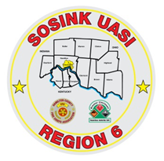
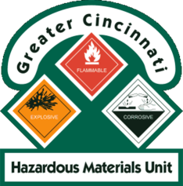
Activity Report
GCHMU
July – August
Runs:
7/12/2018: Freon – Administrative Response – Deerfield Twp
7/15/2018: Diesel Fuel – Administrative Response – Dearborn County, IN
Community Events/Unit Participation:
- Sharonville Touch A Truck – June 4th
Training Completed:
- Warren County LEPC Tabletop Exercise – March 15th
- Monthly In House Training- Paper Use – April 14th
- Clermont County LEPC Tabletop Exercise – April 23rd
- Monthly In House Training – Chemical Suicides & Distribution Ave Case Study- 5/12/2018
- Hamilton County LEPC TTX – May 9th
- Monthly In House Training – Decon /Rail Hazards - 7/14/2018
- Monthly In House Training – Specialty Instrumentation – 8/11/2018
Training Opportunities/Upcoming Events:
- City of Fairfield Touch A Truck – 8/10/2018
- PER 222 Public Safety Sampling Response – Sept 11th -13th

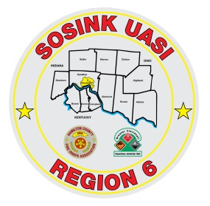
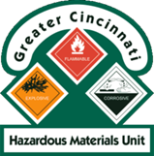
Activity Report
Command 400
July - August
Activations:
None
Community Events/Unit Participation:
- Warren County Fire Chief’s Meeting (Presentation) 4/5/2018
- Warren County Telecomm Open House 4/10/2018
- Glendale Show and Tell 4/16/2018
- Green Township Touch a Truck – 5/12/2018
- Memphis Belle – Wright Patterson AFB - May 16th – May 20th
- Throwback Reunion – Village of Woodlawn – June 1st & 2nd
- Sharonville Touch A Truck – 6/4/2018
- Assumption Festival – Mount Healthy - June 8th and 9th
- Springfield Twp Touch A Truck – June 15th
- Extreme Frisbee Tournament – City of Lebanon – July 14th -21st
- Delhi Skirt Game – Delhi Twp – 8/3/2018
- National Night Out – City of Fairfield – 8/7/2018

Training Completed:
- Monthly In House Training – Social Media – Web EOC- 3/8/2018
- Monthly In House Training – Mobil Sat - 4/12/2018
- Monthly In House Training – Milford Light Truck (support 271) – 5/10/2018
Training Opportunities/Upcoming Events:
- Active Shooter Training – 8/17/2018
- Amberley Village Ice Cream Social – 8/19/2018
- Taste Of Harrison – 9/8/2018
- WPAFB Marathon – Wright Patt – 9/14 & 9/15
- Carriage Festival – City of Lebanon – 12/1/2018

