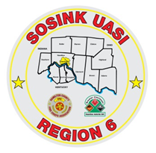
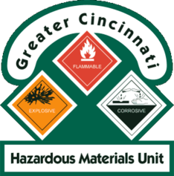
Activity Report
GCHMU
February – March 2018
Runs:
2/5/2018: Cyanide – Administrative Response – City of Fairfield Fire
2/9/2018: Diesel – Administrative Response – City of Forest Park Fire
3/5/2018: Chemical Mixture (Toulene, Benzene, Styrene) – Consultation – City of Carlisle Fire
3/6/2018: Calcium Carbonate – Consultation – Village of New Richmond Fire
3/7/2018: Acetylene – Administrative Response – Village of New Richmond Fire
3/14/2018: Cyanide/Multiple Chemicals – Administrative Response - City of Amelia Police
Community Events/Unit Participation:
HM Training for Clear Creek Fire Dept – Warren County
Show and Tell – City of Evendale – Hamilton County
Training Completed:
- Monthly In House Training – Acids & Oxidizers– 2/10/2018
- Hazardous Materials Tactical Technician Course – 2/16/2018
- Monthly In House Training – PPE – 3/10/2018
- Warren County LEPC TTX – 3/15/2018

Training Opportunities:
- Rail Car Incident Response for Crude, Ethanol, and Other Flam. Liq – April 5th
- Hamilton County LEPC TTX – May 9th
- PER 222 Public Safety Sampling Response – Sept 11th -13th

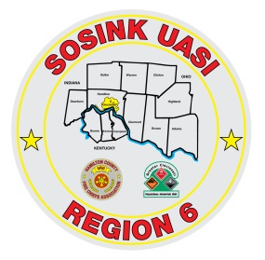
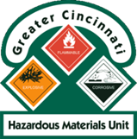
Activity Report
Command 400
February - March 2018
Activations:
None to date
Community Events/Unit Participation:
- Presidential Visit 2/5/2018
Training Completed:
- Monthly In House Training 1/11/2018
- Monthly In House Training 2/8/2018
- Monthly In House Training 3/8/2018
Training Opportunities/Upcoming Events:
- Glendale Show and Tell – 4/16/2018 @ 1830
- Assumption Festival – June 8th and 9th
- Extreme Frisbee Tournament – City of Lebanon – July 14th -21st
- National Night Out – City of Fairfield – August 2018
- Carriage Festival – City of Lebanon – 12/1/2018

