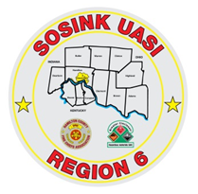
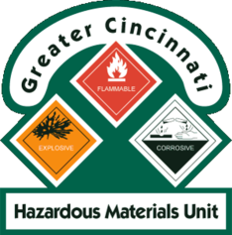
Activity Report
GCHMU
December 2018 – January 2019
Runs:
12/17/2018: Home heating oil spill – Brown County
Community Events/Unit Participation:
None
Training Completed:
- Monthly In House Training – Protein Kits and Incident Command – 12/8/2018
Training Opportunities/Upcoming Events:
- Monthly In House Training – January 26, 2019
- Air Monitoring IQ – January 23, 2019
- Drug IQ – February 28, 2019
- Hazmat Officer/Hazmat Safety Officer - must attend all 3 classes for credit
  - Class 1: March 26, 2019
  - Class 2: April 16, 2019
  - Class 3: May 1, 2019
- Anhydrous Ammonia Live Release Training – May 21-23, 2019 (class repeats daily)
- Chlorine Institute / CSX Trains – July 23 - 25, 2019 (class repeats daily)
- Hazmat Research Specialist – September 25, 2019

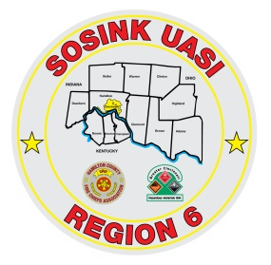
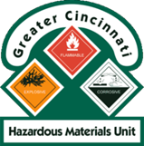
Activity Report
Command 400
December 2018 – January 2019
Activations:
1/1/2019: Water Rescue – Oldenburg Fire Dept, Franklin County, IN
1/8/2019: USAR Activation, Cement Truck into a building – Miami Twp/Milford (Disregard)
Community Events/Unit Participation:
- None

Training Completed:
- Monthly In House Training – 12/13/2018
- Monthly In House Training – 1/10/2019
Training Opportunities/Upcoming Events:
- Monthly Training – 2/14/2018

