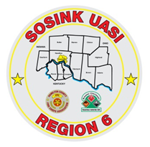
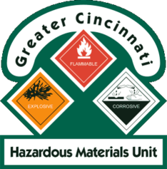
Activity Report
GCHMU
April – May 2018
Runs:
4/20/2018: Mercury – Consultation – Green Township Fire
4/22/2018: Chemical Suicide – Research Team/Duty Officer Response -Village of Fairfax
5/1/2018: Gasoline – Consultation - Franklin Township, Warren County
5/7/2018: Mercury – Administrative Response - City of Fairfield
Community Events/Unit Participation:
None
Training Completed:
- Monthly In House Training- Paper Use - 4/14/2018
- Clermont County LEPC Tabletop Exercise – April 23rd
- Ripley County, IN FSE – April 28th
- Monthly In House Training – Chemical Suicides & Distribution Ave Case Study- 5/12/2018
- Hamilton County LEPC TTX – May 9th
Training Opportunities/Upcoming Events:
- Sharonville Touch A Truck – June 4th
- PER 222 Public Safety Sampling Response – Sept 11th -13th

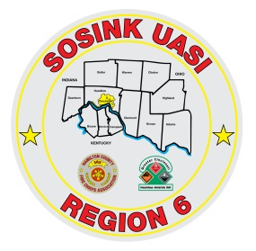
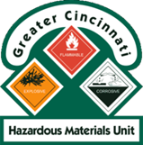
Activity Report
Command 400
April - May 2018
Activations:
None to date
Community Events/Unit Participation:
- Warren County Fire Chief’s Meeting (Presentation) 4/5/2018
- Warren County Telecomm Open House 4/10/2018
- Glendale Show and Tell 4/16/2018
- Green Township Touch a Truck – 5/12/2018
- Memphis Belle – Wright Patterson AFB - May 16th – May 20th

Training Completed:
- Monthly In House Training – Social Media – Web EOC- 3/8/2018
- Monthly In House Training – Mobil Sat - 4/12/2018
- Monthly In House Training – Milford Light Truck – 5/10/2018
Training Opportunities/Upcoming Events:
- Throwback Reunion – Village of Woodlawn – June 1st – 3rd
- Sharonville Touch A Truck – 6/4/2018
- Assumption Festival – June 8th and 9th
- Extreme Frisbee Tournament – City of Lebanon – July 14th -21st
- National Night Out – City of Fairfield – 8/7/2018
- Carriage Festival – City of Lebanon – 12/1/2018

