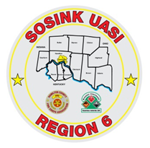
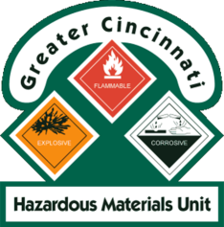
Activity Report
GCHMU
December 2019 – January 2020
Runs:
- 12/22/2019 – Colerain Township
Community Events/Unit Participation:
None
Training Completed:
- Monthly In House Training– 12/14/2019
- Monthly In House Training – 1/11/2020
- Sunman Rural Fire Dept – 1/13/2020

Training Opportunities/Upcoming Events:
- Hazmat Tactical Technician – February 25th, 26th, 27th (repeats daily)
- Tank Truck Workshop – March 17th and 18th
- Warren County Full Scale LEPC Exercise – March 19th
- Ethanol Emergencies and Foam Application – July 24th, 25th, 26th (repeats daily)
- HM Containers – August 11th
- Pipeline Emergencies – August 11th
- Managing Gas Emergencies – September 22nd

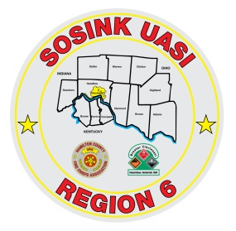
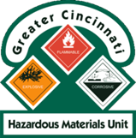
Activity Report
Command 400
December 2019 – January 2020
Activations:
- Colerain Township– 12/22/2019
Community Events/Unit Participation:
None
Training Completed:
- Monthly In House Training – 12/12/2019
- Monthly In House Training – 1/9/2020
- Sunman Rural Fire Dept – 1/13/2020
Training Opportunities/Upcoming Events:
- Monthly In House Training – February 13th
- Warren County Full Scale LEPC Exercise – March 19th

