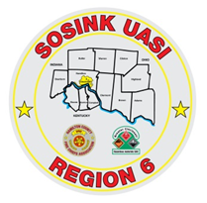
Activity Report
GCHMU
March 2020 – April 2020
Runs:
None
Community Events/Unit Participation:
None
Training Completed:
- Monthly In House Training – 3/14/2020 CANCELLED
- Monthly In House Training – 4/11/2020 CANCELLED
Training Opportunities/Upcoming Events:
- Ethanol Emergencies and Foam Application – July 24th, 25th, 26th (repeats daily) (CANCELLED)
- HM Containers – August 11th
- Pipeline Emergencies – August 11th
- Managing Gas Emergencies – September 22nd

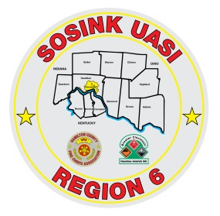

Activity Report
Command 400
March 2020 – April 2020

Activations:
None
Community Events/Unit Participation:
- Officer Grant Procession
Training Completed:
- Monthly In House Training – 3/12/2020 CANCELLED
- Monthly In House Training – 4/9/2020 CANCELLED
Training Opportunities/Upcoming Events:
- Sharonville Touch a Truck – June 8th
- Springfield Township Touch a Truck – June 19th
- Colerain Township Fireworks – July 3rd

