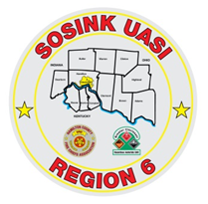
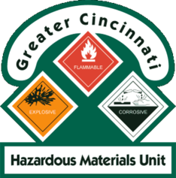
Activity Report
GCHMU
January 2022- February 2022
Runs:
- 2/9/2021 – Consultation – Oil Leak – Turtlecreek Twp
- 2/22/2022 – Administrative – Unknown Rust Foamy Substance – City of Sharonville
Community Events/Unit Participation:
None
Training Completed:
- Monthly In House Training – Chlorine - 2/12/2022

Training Opportunities/Upcoming Events:
- Monthly In House Training – March 13th
- Clinton County Exercise – March 18th
- Hazmat IQ –March 21st
- Hamilton County Tabletop LEPC Exercise – March 23rd
- Surviving the Hot Zone – April 1st & April 2nd
- Warren County Tabletop LEPC Exercise – April 20th
- Decon IQ- April 27th
- Propane IQ – May 9th & 10th

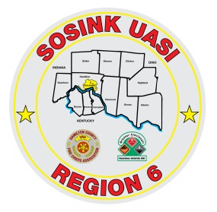
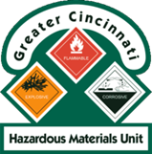
Activity Report
Command 400
January 2022- February 2022
Activations:
2/11/2022 – Missing Person – Miami Twp (Clermont County) - Disregarded
Community Events/Unit Participation:
None
Training Completed:
- Monthly In House Training – 2/10/2021
Training Opportunities/Upcoming Events:
- Monthly In House Training – March 10th
- Clinton County Exercise – March 18th
- Extreme World Frisbee Tournament – July 23rd – July 30th

