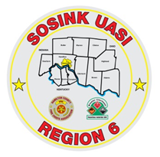
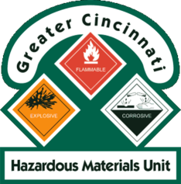
Activity Report
GCHMU
January 2020 – February 2020
Runs:
- 2/3/2020 – Clinton County EMA – unknown substance
- 2/18/2020 – Morgan Twp – Structure Fire
Community Events/Unit Participation:
None
Training Completed:
- Monthly In House Training – 1/11/2020
- Sunman Rural Fire Dept – 1/13/2020
- Monthly In House Training – 2/8/2020
Training Opportunities/Upcoming Events:
- Hazmat Tactical Technician – February 25th, 26th, 27th (repeats daily)
- Tank Truck Workshop – March 17th and 18th
- Warren County Full Scale LEPC Exercise – March 19th
- Ethanol Emergencies and Foam Application – July 24th, 25th, 26th (repeats daily)
- HM Containers – August 11th
- Pipeline Emergencies – August 11th
- Managing Gas Emergencies – September 22nd

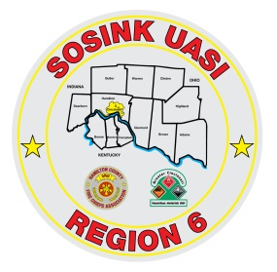
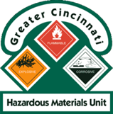
Activity Report
Command 400
January 2020 – February 2020
Activations:
- 2/18/2020 – Morgan Twp – Structure Fire
Community Events/Unit Participation:
None
Training Completed:
- Monthly In House Training – 1/9/2020
- Sunman Rural Fire Dept – 1/13/2020
- Monthly In House Training – 2/13/2020
Training Opportunities/Upcoming Events:
- Warren County Full Scale LEPC Exercise – March 19th
- Blue Ash Touch a Truck – May 20th
- Sharonville Touch a Truck – June 8th
- Springfield Township Touch a Truck – June 19th
- Colerain Township Fireworks – July 3rd

