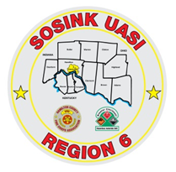
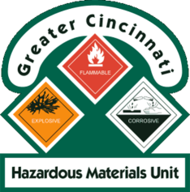
Activity Report
GCHMU
April 2020 – May 2020
Runs:
5/26/2020 – Diesel Fuel/Gasoline Spill – Turtlecreek Township
Community Events/Unit Participation:
None
Training Completed:
- Monthly In House Training – 4/11/2020 Cancelled
- Monthly In House Training – 5/9/2020 Cancelled
Training Opportunities/Upcoming Events:
- Ethanol Emergencies and Foam Application – July 24th, 25th, 26th (repeats daily) (CANCELLED)
- HM Containers – August 11th
- Pipeline Emergencies – August 11th
- Managing Gas Emergencies – September 22nd

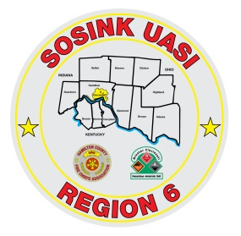
Activity Report
Command 400
April 2020 – May 2020

Activations:
None
Community Events/Unit Participation:
- Officer Grant Procession
- D/C Chetwood Procession
Training Completed:
- Monthly In House Training – 4/9/2020 Cancelled
- Monthly In House Training – 5/14/2020 Cancelled
Training Opportunities/Upcoming Events:
- Sharonville Touch a Truck – June 8th
- Springfield Township Touch a Truck – June 19th
- Colerain Township Fireworks – July 3rd - CANCELLED

