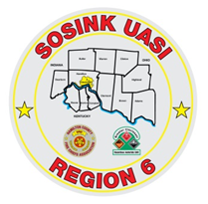
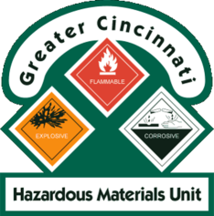
Activity Report
GCHMU
May 2020 – June 2020
Runs:
5/26/2020 – Diesel Fuel/Gasoline Spill – Turtlecreek Twp
6/11/2020 – Consultation – Green Twp
6/17/2020 – Urea Ammonium Nitrate – City of Franklin
Community Events/Unit Participation:
None
Training Completed:
- Monthly In House Training – 5/9/2020 Cancelled
- Monthly In House Training – 6/13/2020
Training Opportunities/Upcoming Events:
- Ethanol Emergencies and Foam Application – July 24th, 25th, 26th (repeats daily) (CANCELLED)
- HM Containers – August 11th
- Pipeline Emergencies – August 11th
- Tank Truck Emergency Response Workshop – September 9th and 10th
- Managing Gas Emergencies – September 22nd

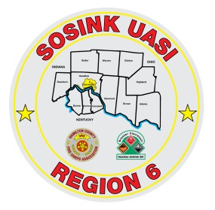
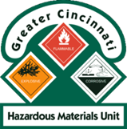
Activity Report
Command 400
May 2020 – June 2020

Activations:
None
Community Events/Unit Participation:
- D/C Chetwood Procession 5/11/2020
- Police Request – 6/7/2020

Training Completed:
- Monthly In House Training – 5/14/2020 Cancelled
- Monthly In House Training – 6/11/2020
Training Opportunities/Upcoming Events:
- Monthly In House Training - 7/11/2020

