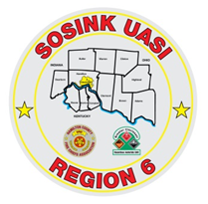
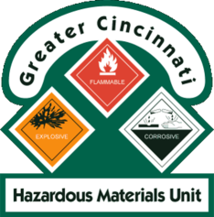
Activity Report
GCHMU
July 2020 – August 2020
Runs:
7/19/2020- Administrative Consultation – Propane – Harrison Fire
7/22/2020 – Administrative Response – Unknown liquid – Sycamore Twp
7/27/2020 – Administrative Response - Unknown Oily substance – Blue Ash
7/29/2020 – Administrative Consultation – Disinfectant Concentrate– Little Miami Fire & Rescue
8/13/2020 – Administrative Response – Tar in roadway – Miami Twp (Ham Co)
8/14/2020 – Administrative Response -Unknown Oily substance – Blue Ash
8/14/2020 – Administrative Response - Fuming Drum – City of Mason
8/14/2020 – Administrative Response – Freon – Deerfield Twp
Community Events/Unit Participation:
None
Training Completed:
- Monthly In House Training – 7/11/2020
- Tactical Technician (Tactical Chemistry for First Responders) – ONLINE – to register: www.drhazmat.com July 20th, 21st and 22nd (repeats daily)
- Monthly In House Training – 8/15/2020
Training Opportunities/Upcoming Events:
- Tank Truck Emergency Response Workshop – September 9th and 10th @ BAFD
- Monthly In House Training – 9/12/2020
- Managing Gas Emergencies – September 22nd
- Monthly In House Training – 10/10/2020

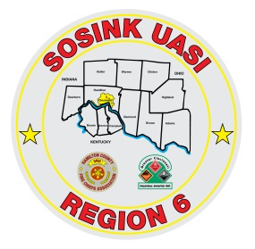
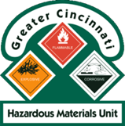
Activity Report
Command 400
July 2020 – August 2020

Activations:
None
Community Events/Unit Participation:
- Police Request – 6/7/2020

Training Completed:
- Monthly In House Training - 7/11/2020
- Monthly In House Training - 8/8/2020
Training Opportunities/Upcoming Events:
- Monthly In House Training - 9/10/2020

