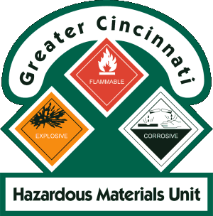
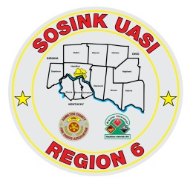
Greater Cincinnati Hazmat Unit
1881 E Crescentville Road, Sharonville, OH 45246
513-779-1200 Office, 513-779-0703 Fax
brmatzen@gmail.com

Team Organization:
Non Profit regional team organized by the Hamilton County Fire Chief’s Association and the Northern Kentucky Firefighter’s Association.
GCHMU is governed by a Board of Trustees representing the fire service, the public, local government and tri state businesses.
GCHMU is able to respond to both major and minor incidents. The team has over 20 years of experience and is capable of handling multiple incidents at one time, making multiple entries and sustaining a 24 hour operation.
Our detection equipment also contains the instrumentation to respond to incidents involving Chemical, Biological or Radiological agents.
Our personnel consist of predominately professional fire fighters, EMT’s, Paramedics and industry representatives from across the tri state.
The team is led by 3 Part Time Duty Officers: Chief Don Bennett, Chief BJ Jetter and Dennis Waldbillig. One duty officer is always on call year round.
To access the Duty Officers, one must call the Hamilton County Comm Center at 513-825-2280 and ask to have the On Call GCHMU Duty Officer paged. **Remember to leave a good call back number.
In addition to the Duty Officers, GCHMU has 1 Full Time Office Administrator: Brooke Matzen
Office Hours: M-F 8am – 4 pm
Currently, GCHMU carries 115 Hazmat Technicians and Support Personnel from varying agencies as well as multiple Research Members
GCHMU has been verified as a Type 1 team in the State of Ohio – Highest level. This certifies them to deal with Known and Unknown Chemicals as wells as WMD, Radiological and Biological Chemical substances.
Training:
GCHMU trains monthly on the 2nd Saturday of every month and participates in local and regional LEPC Exercises annually

Greater Cincinnati Hazmat Unit
1881 E Crescentville Road, Sharonville, OH 45246
513-779-1200 Office, 513-779-0703 Fax
brmatzen@gmail.com

Response Units:
2 Truck and Trailer Combinations – PPE and equipment required for entry
Sharonville, OH / Deerfield Twp, OH
1 Analytical Response Unit – All monitor and Detection Equipment
Sharonville, OH
1 Foam Truck – Contain AR-AFFF Foam, 2 foam nozzles that flow 500 gpm
City of Fairfield, OH
2 Duty Officer Response Trucks
2 Gators
Sharonville, OH / Deerfield Township, OH (Warren County)
2 Absorbent Trailers – fully stocked with booms, pads, pillows, Spill X Products
City of Fairfield, OH / TBD
Response Procedures:
All response is in accordance with NIMS. The team is dispatched through the Hamilton County Communications Center after a request has been received from the local Police or Fire Dept. The Incident Commander contacts the Communications Center and asks to speak to the On Call Duty Officer. They will then determine the level of response needed:
Administrative Consultation: The IC may request a Duty Officer for a phone consultation for resources and information such as contact with a Chemist, Clean-Up Contractor etc.
Administrative Response: A Duty Officer only, responds to the scene and provides detection equipment and expertise in mitigation.
Full Team Response: Full Response by Duty Officers, Chemists, Technicians and appropriate apparatus.

