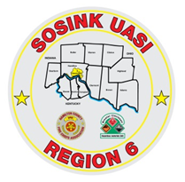
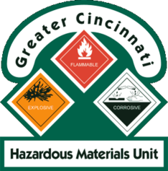
Activity Report
GCHMU
May – June 18, 2018
Runs:
5/1/2018: Gasoline – Consultation - Franklin Township, Warren County
5/7/2018: Mercury – Administrative Response - City of Fairfield
5/29/2018: Foam Truck Response to Recycling Center Fire – City of Mason
6/6/2018: Chromium and Lead – Consultation – Ripley County, IN
6/21/2018: Unknown White Powder – Administrative Response – Sycamore Twp
Community Events/Unit Participation:
- Sharonville Touch A Truck – June 4th
Training Completed:
- Warren County LEPC Tabletop Exercise – March 15th
- Monthly In House Training- Paper Use – April 14th
- Clermont County LEPC Tabletop Exercise – April 23rd
- Monthly In House Training – Chemical Suicides & Distribution Ave Case Study- 5/12/2018
- Hamilton County LEPC TTX – May 9th
Training Opportunities/Upcoming Events:
- PER 222 Public Safety Sampling Response – Sept 11th -13th

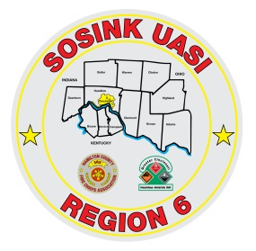
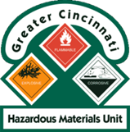
Activity Report
Command 400
May – June 18, 2018
Activations:
5/24/2017: 481 Wayne Street - Fire Investigation – City of Cincinnati
5/26/2017: 6960 Blue Rock Road – Water Rescue/Recovery – Colerain Twp - DISREGARDED
Community Events/Unit Participation:
- Warren County Fire Chief’s Meeting (Presentation) 4/5/2018
- Warren County Telecomm Open House 4/10/2018
- Glendale Show and Tell 4/16/2018
- Green Township Touch a Truck – 5/12/2018
- Memphis Belle – Wright Patterson AFB - May 16th – May 20th
- Throwback Reunion – Village of Woodlawn – June 1st & 2nd
- Sharonville Touch A Truck – 6/4/2018
- Assumption Festival – Mount Healthy - June 8th and 9th
- Springfield Twp Touch A Truck – June 15th
Training Completed:
- Monthly In House Training – Social Media – Web EOC- 3/8/2018
- Monthly In House Training – Mobil Sat - 4/12/2018
- Monthly In House Training – Milford Light Truck (support 271) – 5/10/2018
Training Opportunities/Upcoming Events:
- Extreme Frisbee Tournament – City of Lebanon – July 14th -21st
- National Night Out – City of Fairfield – 8/7/2018
- Carriage Festival – City of Lebanon – 12/1/2018

