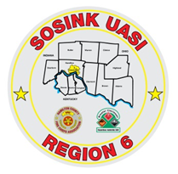
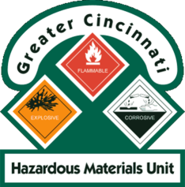
Activity Report
GCHMU
January – February 2018
Runs:
1/30/2018: Mercury – Administrative Response – Blue Ash Fire
2/5/2018: Cyanide – Administrative Response – City of Fairfield Fire
2/9/2018: Diesel – Administrative Response – Forest Park Fire
Community Events/Unit Participation:
HM Training for Clear Creek Fire Dept – Warren County
Training Completed:
- HM IQ – 1/12/2018
- Clan Lab Training – 1/16/2018
- Monthly In House Training – Acids & Oxidizers– 2/10/2018
- Hazardous Materials Tactical Technician Course – 2/16/2018

Training Opportunities:
- Warren County LEPC TTX – March 15th
- Clermont County LEPC TTX – March 21st
- Rail Car Incident Response for Crude, Ethanol, and Other Flam. Liq – April 5th
- Hamilton County LEPC TTX – May 9th

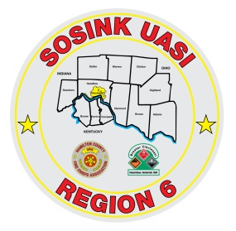
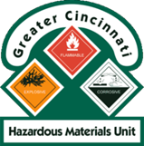
Activity Report
Command 400
January – February 2018
Activations:
None to date
Community Events/Unit Participation:
- Presidential Visit 2/5/2018
Training Completed:
- Monthly In House Training 1/11/2018
- Monthly In House Training 2/8/2018
Training Opportunities:
- Glendale Show and Tell – 4/16/2018 @ 1830
- Assumption Festival – June 8th and 9th
- Extreme Frisbee Tournament – City of Lebanon – July 14th -21st
- National Night Out – City of Fairfield – August 2018
- Carriage Festival – City of Lebanon – 12/1/2018

