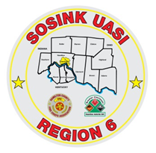
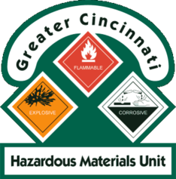
Activity Report
GCHMU
October - November
Runs:
10/19/2018 Unknown Odor – Administrative Consultation – Dearborn County, IN
10/19/2018 Unknown Liquid in Drum – Administrative Consultation – Brown County
10/26/2018 Suspected Opioid Exposure – Administrative Consultation – Dearborn County, IN
Community Events/Unit Participation:
None
Training Completed:
- Monthly in-House Training – Hydrocarbons, Clandestine Labs, Household Hazards and Transportation Incidents 10/13/18
- Monthly In House Training – WMD 11/10/2018
Training Opportunities/Upcoming Events:
- Monthly in-House Training – 12/8/2018
- Air Monitoring IQ – January 23, 2019
- Drug IQ – February 28, 2019
- Hazmat Officer/Hazmat Safety Officer - must attend all 3 classes for credit
  - Class 1: March 26, 2019
  - Class 2: April 16, 2019
  - Class 3: May 1, 2019
- Anhydrous Ammonia Live Release Training – May 21-23, 2019 (class repeats daily)
- Chlorine Institute / CSX Trains – July 23 - 25, 2019 (class repeats daily)

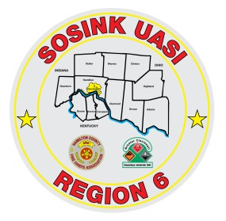
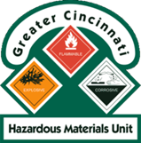
Activity Report
Command 400
October - November
Activations:
None
Community Events/Unit Participation:
- WPAFB Air Force Marathon – Wright Patterson – 9/13 - 9/15
- Oktoberfest Zinzinnati – 9/21 – 9/23
- Deer Park Business Association Meeting – 10/3/2018

Training Completed:
- Monthly in-House Training – 9/20/2018
- Monthly in-House Training – 10/11/2018
- Monthly in-House Training – 11/8/2018
- USAR Training – 11/14, 11/15
Training Opportunities/Upcoming Events:
- Carriage Festival – City of Lebanon – 12/1/2018

