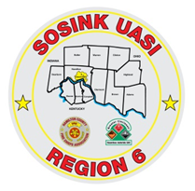
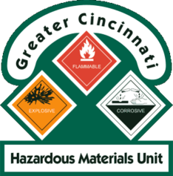
Activity Report
GCHMU
November – December 13th
Runs:
11/28/2018 – Administrative Consultation - St. Bernard Fire – Sodium Hydroxide
Community Events/Unit Participation:
None
Training Completed:
- Monthly In House Training – WMD 11/10/2018
- Monthly In House Training – Protein Kits and Incident Command – 12/8/2018
Training Opportunities/Upcoming Events:
- Air Monitoring IQ – January 23, 2019
- Drug IQ – February 28, 2019
- Hazmat Officer/Hazmat Safety Officer - must attend all 3 classes for credit
  - Class 1: March 26, 2019
  - Class 2: April 16, 2019
  - Class 3: May 1, 2019
- Anhydrous Ammonia Live Release Training – May 21-23, 2019 (class repeats daily)
- Chlorine Institute / CSX Trains – July 23 - 25, 2019 (class repeats daily)
- Hazmat Research Specialist – September 25, 2019

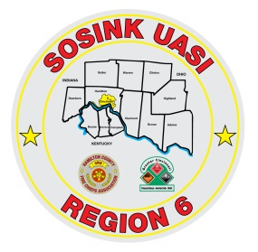
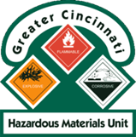
Activity Report
Command 400
November – December 13th
Activations:
None
Community Events/Unit Participation:
- None

Training Completed:
- Monthly in-House Training – 11/8/2018
- USAR Training – 11/14, 11/15
- Monthly In House Training – 12/13/2018
Training Opportunities/Upcoming Events:
- None

