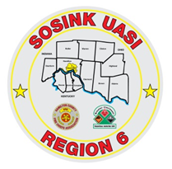
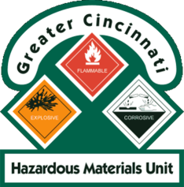
Activity Report
GCHMU
June 2020 – July 2020
Runs:
6/11/2020 – Consultation – Green Twp
6/17/2020 – Urea Ammonium Nitrate – City of Franklin, Warren County
7/22/2020 – Administrative Response – Unknown liquid – Sycamore Twp
7/27/2020 – Administrative Response - Unknown Oily substance – Blue Ash
Community Events/Unit Participation:
None
Training Completed:
- Monthly In House Training – 6/13/2020
- Monthly In House Training – 7/11/2020
Training Opportunities/Upcoming Events:
- Tactical Technician (Tactical Chemistry for First Responders) – ONLINE – to register: www.drhazmat.com July 20th, 21st and 22nd (repeats daily)
- Ethanol Emergencies and Foam Application – July 24th, 25th, 26th (repeats daily) (CANCELLED)
- HM Containers – August 11th (CANCELLED)
- Pipeline Emergencies – August 11th (CANCELLED)
- Tank Truck Emergency Response Workshop – September 9th and 10th
- Managing Gas Emergencies – September 22nd

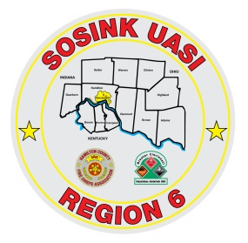
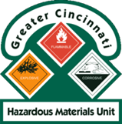
Activity Report
Command 400
June 2020 – July 2020

Activations:
None
Community Events/Unit Participation:
- Police Request – 6/7/2020

Training Completed:
- Monthly In House Training – 6/11/2020
- Monthly In House Training - 7/11/2020
Training Opportunities/Upcoming Events:
- Monthly In House Training - 8/8/2020

